Fiji:

Open data

Choose ROI

Mack a substack

Image-adjust- threshold

Analyze- set scale

#Image- properties- set the scale in um- better to do with the set scale

Plugin-bonej-slice geometry

Plot the Mean Thick 3D (¬µm) by slice from the csv file

In bone J do the thickness map (BoneJ-thickness)

#For 3d image use the second option-no needmaiA screenshot of a computer

AI-generated content may be incorrect.

Option for 3d image:

Plugin -3d viewer

Image-stack-3d project

After the thickness map to get scale bar:

Analyse-tools-calibration bar

To add ROI

### Step-by-step: Resample Z-spacing from 20 µm → 15 µm in Fiji

#### ✅ 1. Calculate the Z scale factor:

Old spacing/New spacing=2015=1.333\text{Old spacing} / \text{New spacing} = \frac{20}{15} = 1.333Old spacing/New spacing=1520​=1.333

So you’ll **scale Z by 1.333**, which means you’ll end up with **more slices**, spaced at **15 µm**.

### ✅ 2. Use **Image > Scale...**

1. Open your stack in Fiji.
2. Go to **Image > Scale...**
3. Set:
   * **X scale:** 1.0
   * **Y scale:** 1.0
   * **Z scale:** **1.333**
4. Make sure **"Interpolate"** is **checked** (this ensures smooth data between slices).
5. Confirm **“Process all slices”** is selected.
6. Click **OK**

### Step-by-step: Resample Z-spacing from 15 µm → 20 µm

#### ✅ 1. Install “TransformJ” plugin (if needed)

* Check if you have **TransformJ** installed (under Plugins > TransformJ > Scale).
* If not, install it via **Update Sites** or use the built-in Scale... from **Image > Scale**.

#### ✅ 2. Calculate the new Z scale factor:

New Z spacing/Old Z spacing=2015=1.333\text{New Z spacing} / \text{Old Z spacing} = \frac{20}{15} = 1.333New Z spacing/Old Z spacing=1520​=1.333

So you’ll scale the Z dimension by **0.75** (since you’re going **from 15 → 20**, you need **fewer** slices):

1520=0.75\frac{15}{20} = 0.752015​=0.75

#### ✅ 3. Use Image > Scale...

* Go to **Image > Scale...**
* Set:
  + **X scale:** 1.0
  + **Y scale:** 1.0
  + **Z scale:** **0.75**
* Check or uncheck **Interpolate** depending on whether you want smooth transitions.
* Make sure **"Process all slices"** is checked (if available).
* Click **OK**

After open the data I need to oriented to the same orientation.

Loot at the data with reslize option to make it all horizontal

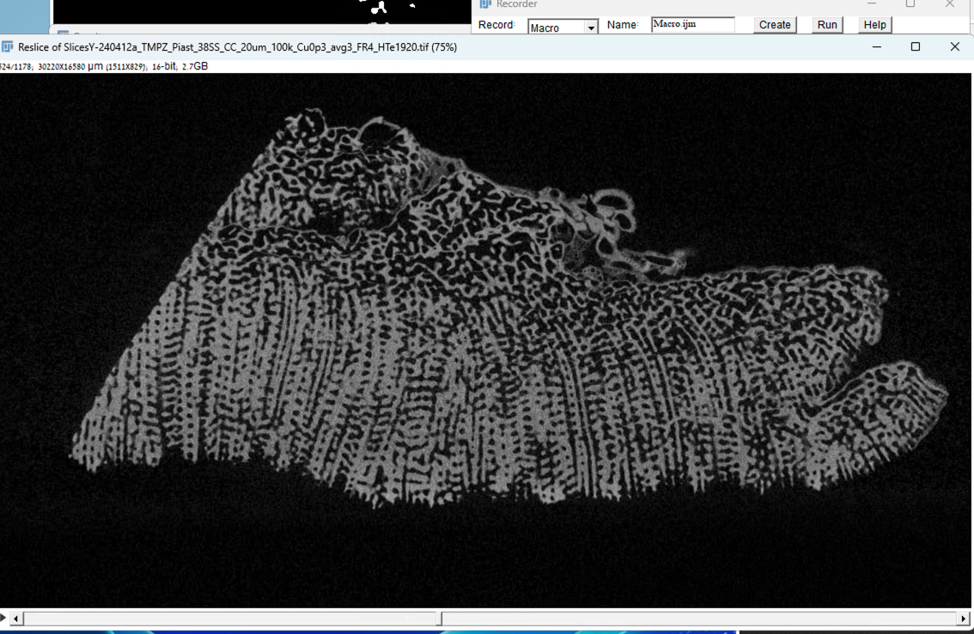

Save with ROI as Tif

Save substuck flip to vertical and threshold and run boneJ

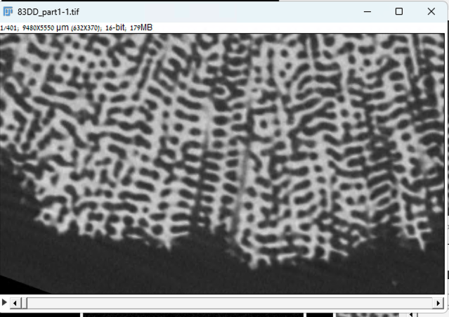

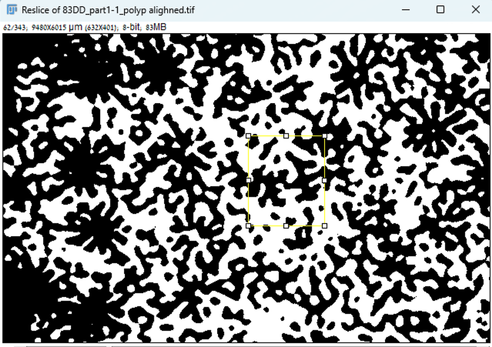

Comparing the SD of the thickness analysis of each sample shows that the deep corals are similar and the SD of the shallow ones is much bigger, which can be due to the different thickness of strata or maybe there are thicker area like septa

To check this, we will use AI to train the data for the segmentation and to see if the threshold conversion didn’t introduce bias,

In Fiji

Open the ROI

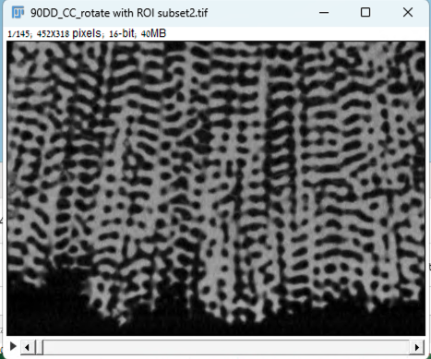

Reslice from bottom

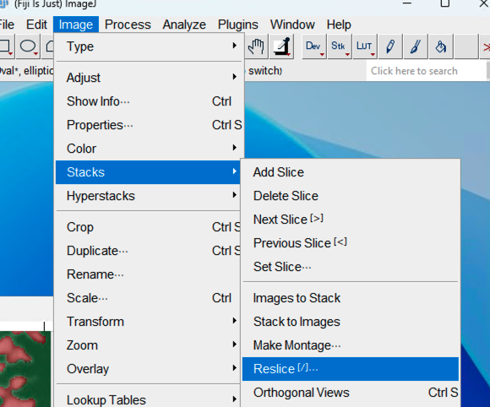

Plugin🡪Segmentation 🡪 trainable weka segmentation

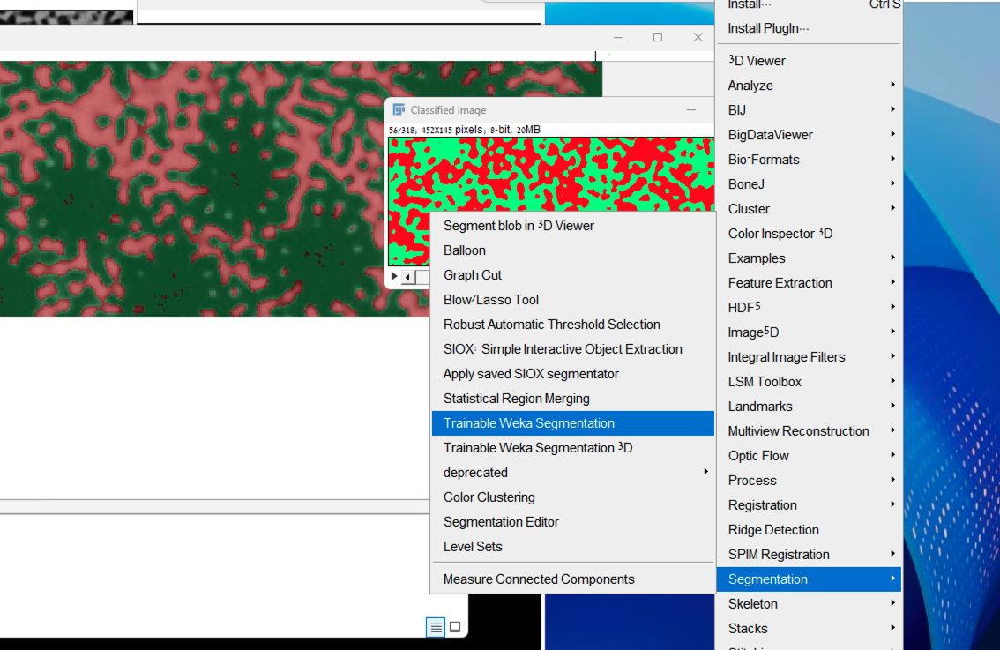

After open:

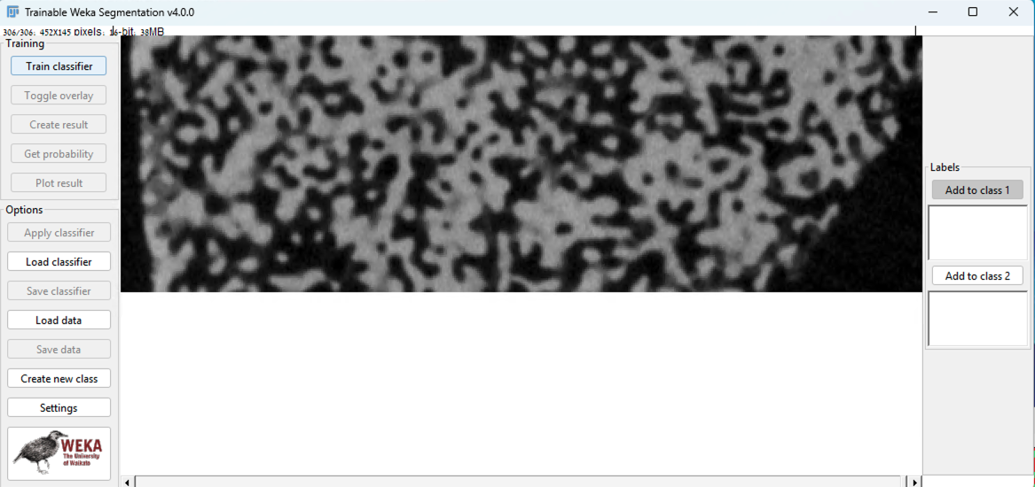

In setting rename the labels of the class

Using the freehand tool, mark the area at each section and add to the relevant class, repeat in about 20 slices

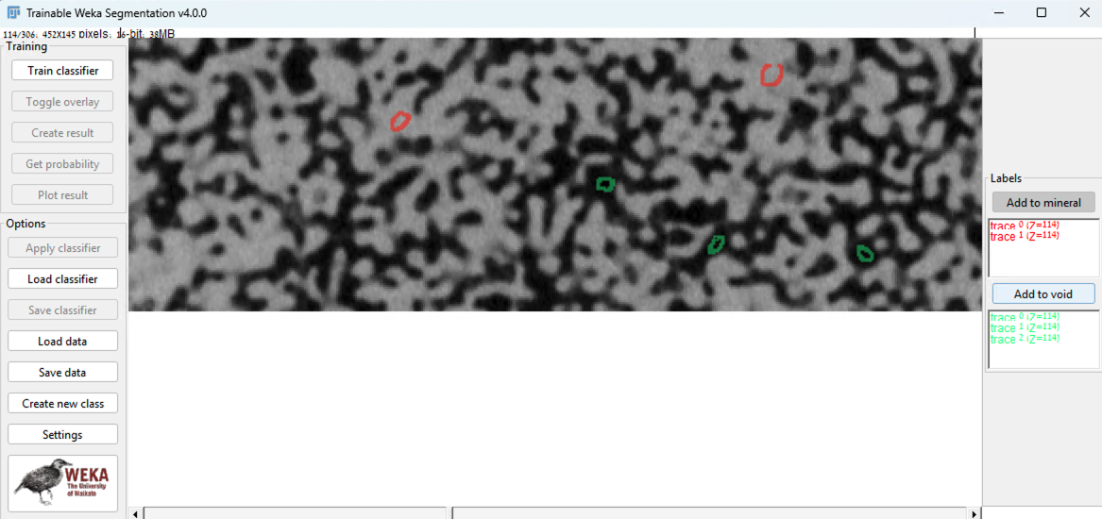

Once have it use the train classifier option

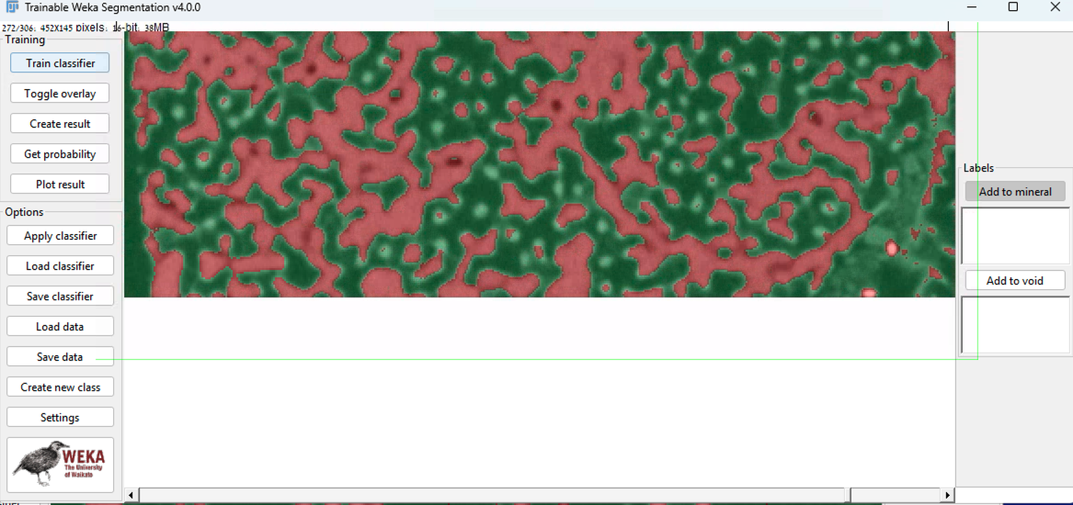

Check the results and creat results if ok

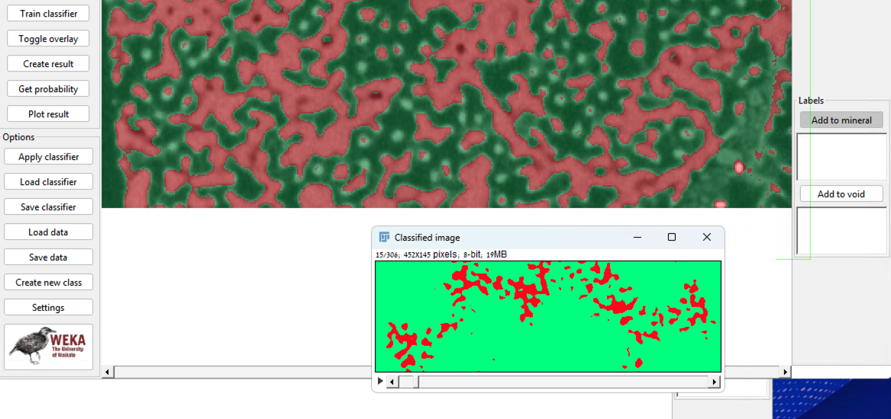

Adjust threshold to BW again and run boneJ.

Calculate porosity in boneJ:

#### **Thresholding to Segment Voids**

* Image > Adjust > Threshold…
  + Choose an appropriate method (e.g., Otsu, Li, Manual).
  + Ensure **voids are highlighted** (usually darker areas).
  + **Important**: Set background as black and foreground as white (or vice versa, depending on convention).

#### 4. **Convert to Binary**

* After thresholding, click **Apply** to create a binary image.
* In this image:
  + **Void regions** = White (255)
  + **Solid material** = Black (0) — or vice versa, depending on your threshold.

**BoneJ Plugin**: Offers a direct porosity measurement.

* Install via: Help > Update > Manage Update Sites > BoneJ
* Then use: Plugins > BoneJ > Volume Fraction

In **BoneJ**, the **"Volume Fraction"** tool calculates the **porosity of the full 3D stack**, **not per slice**.

Specifically:

* **Volume fraction** in BoneJ is defined as:

